Beno’s Bulletin
December 2022

Principal’s Christmas Message.
As we approach the end of 2022 I would like to take this opportunity to wish
you all a wonderful Christmas. May you have plenty of festive joy and may
Santa bring presents for each girl and boy.
Embrace the atmosphere and be filled with Christmas cheer!
Merry Christmas
from Ms. Plunkett

Neron was followed by seagulls after he ran away...Mark’s friend kicked his football and it disappeared...Emily Ray got stuck in the splits...Alfie won a prize...Kelsey saw one dog eat two footballs…. Aaron got stuck in the ball pit….. Calum slipped on the ice... ouch!....Denver’s bike broke…. Lorcan ran into his Nannys house…. Clayton went to London and threw a big snowball at his dad…. Kyra went to the Panto…. Kara is going to Wexford…. The tiger was banging on the glass at Bobby…. Charlie will win 80 or 200 euro…. James’ dog ate plastic….. Amber’s elf turned off the electricity…. Darcey’s elf cut holes in her pyjamas…. Kayla put up her tree…. Thomas is going to the Panto and McDonalds….Jasmine’s cat is a corndog….Sadie is going to a wedding but she’s not the bride….Juliette went to the plex and had a disco by herself in the tiger area….Santa came to Abigail’s road last night….Cooper can get a nintendo switch when he’s 7 but sometimes his uncle Glen lets him play his….Hudson had to go to Hostipal cause he had a fracture….

Marshmallow Snowball Dippers
Ingredients
- 150g dark chocolate, broken into pieces
- 4 candy canes (or 16 lollipop sticks)
- 16 marshmallows
- 4 tbsp desiccated coconut, or 6 tbsp sprinkles, stars, or
- hundreds and thousands (or a mix)

Method
- Melt the chocolate in the microwave or a bowl over simmering water, then pour into a smaller bowl or shallow cup where the marshmallows can be individually submerged easily (too shallow and they’re harder to dunk). Leave for a few mins to cool slightly.
- While the chocolate is cooling, break the candy canes into 4 equal pieces (a few pieces will be slightly hooked but that’s ok). Insert a piece of candy cane (or lollipop stick) into each marshmallow in the wider end. Line 2 boards or trays with baking paper and arrange a cooling rack over one of them. Put your coconut or sprinkles into small bowls.
- Dunk the marshmallows into the chocolate – use a spoon to drizzle over the top of them if you need to (the chocolate around the top will help to keep them stuck when set). Let any excess drip off back into the bowl, then transfer to the cooling rack. Repeat with all the marshmallows.
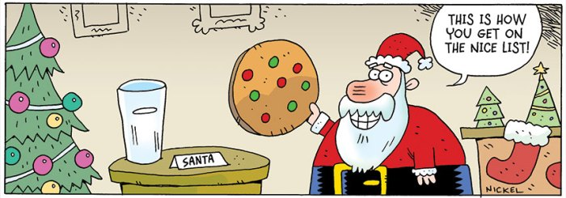
- Once the chocolate has stopped dripping and is starting to set, hold the dippers over the coconut or sprinkle bowls and scatter pinches over them, spinning to coat all over (any falling off will go back into the bowl). Once coated, leave to set on the baking paper for at least 1 hr in a cool place. Keep in a cool place for 2 weeks if using lollipop sticks, 2-3 days if using candy canes.

Gg

CHRISTMAS CONCERT
After three long years our annual Christmas show returned more spectacular than ever before. The children were very excited to perform for the audience who were entertained with singing, dancing and acting from our very talented pupils. Everyone would agree that the children sparkled and shone on stage and spread Christmas cheer.
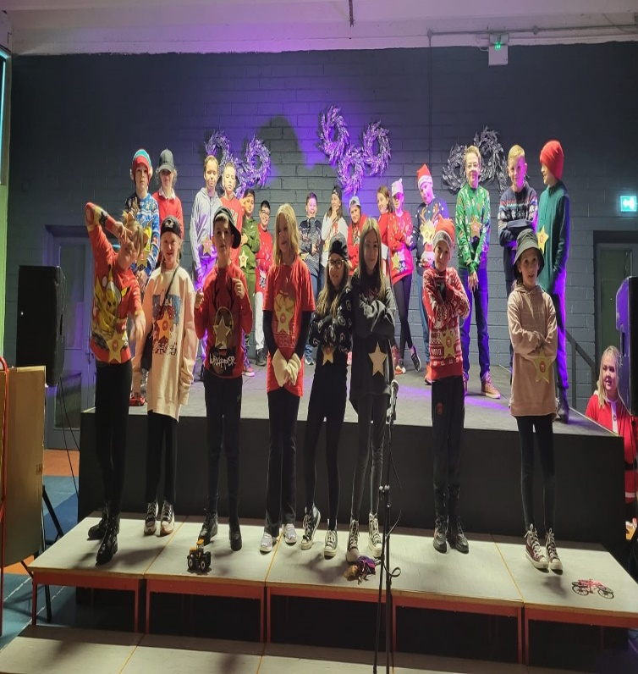
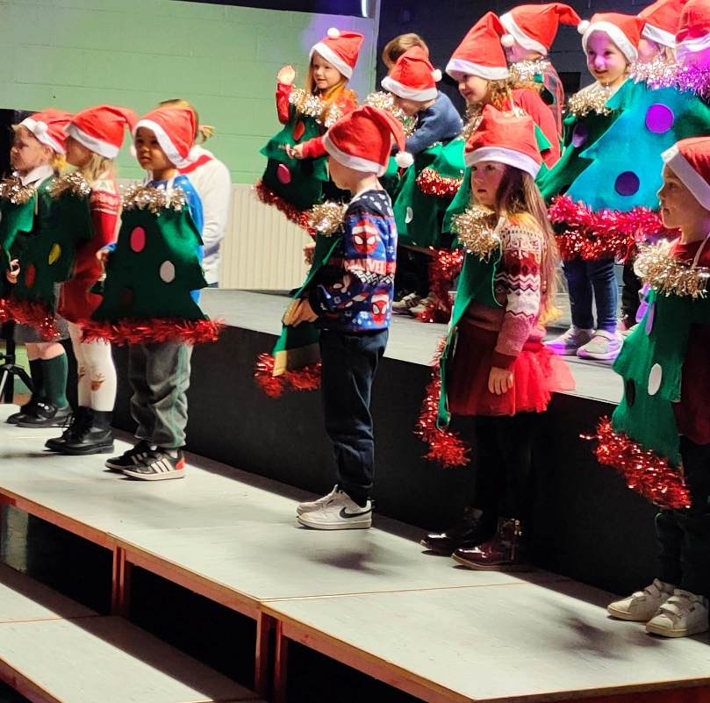

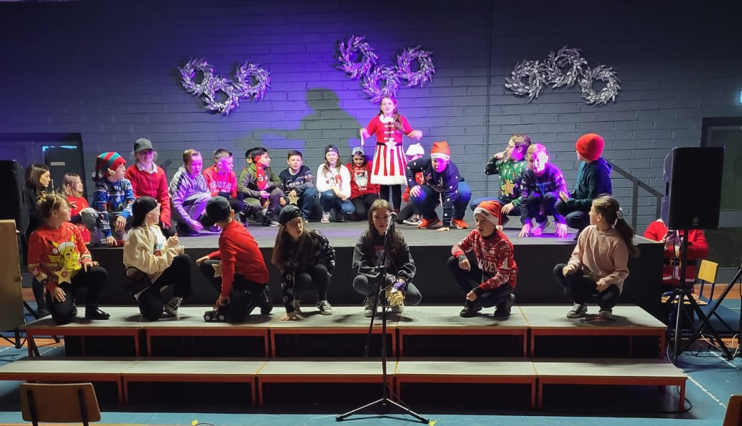

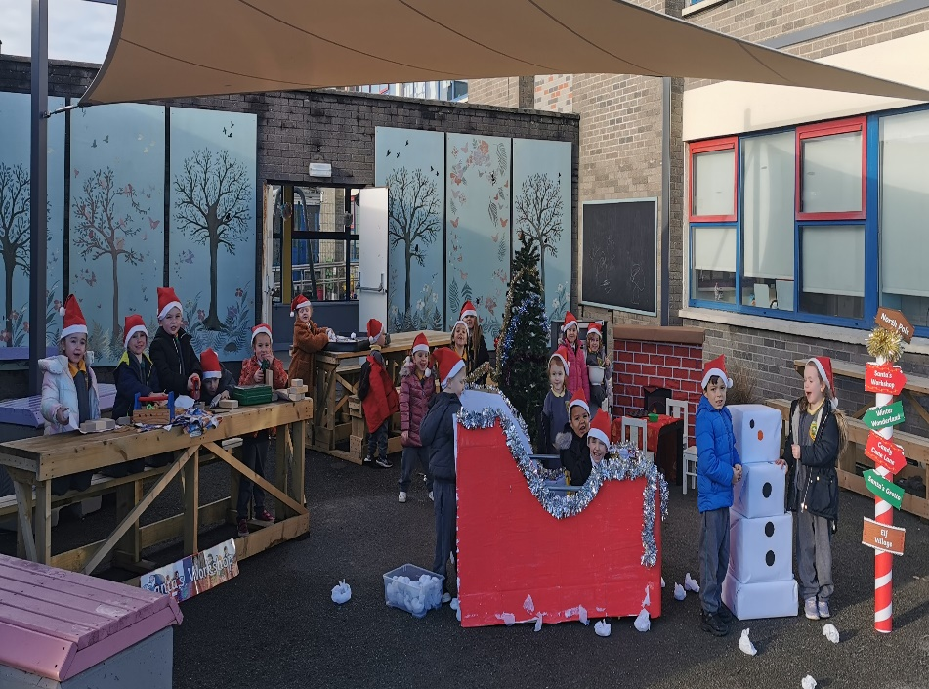
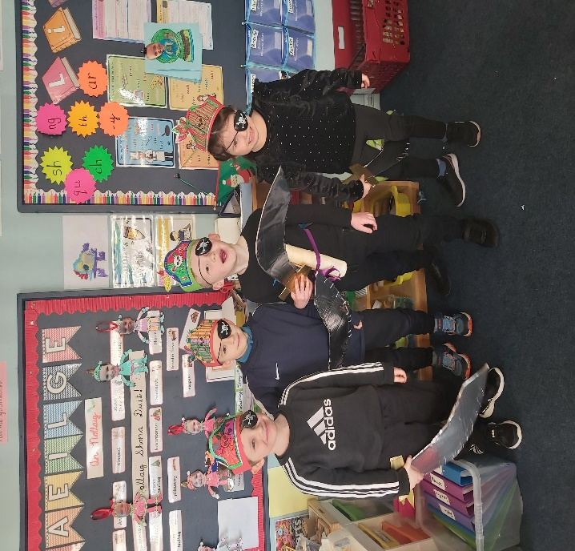

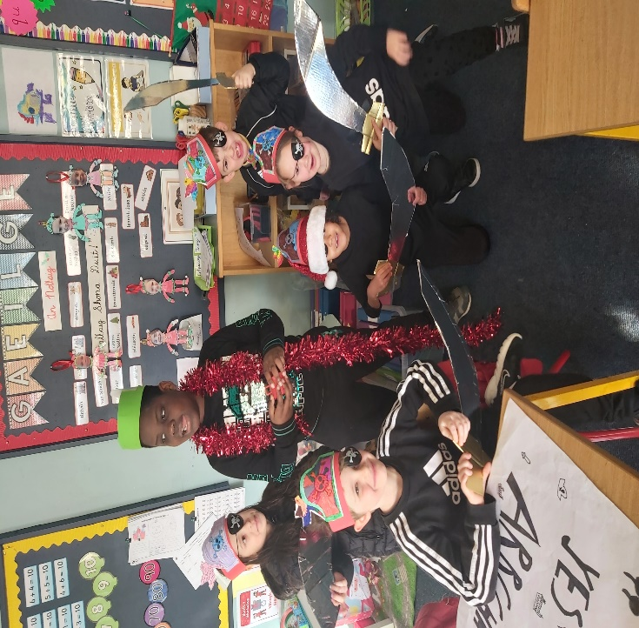
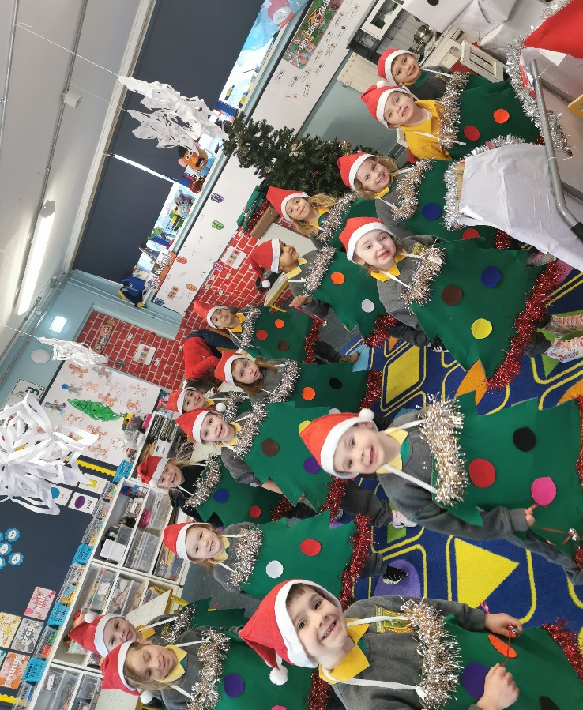

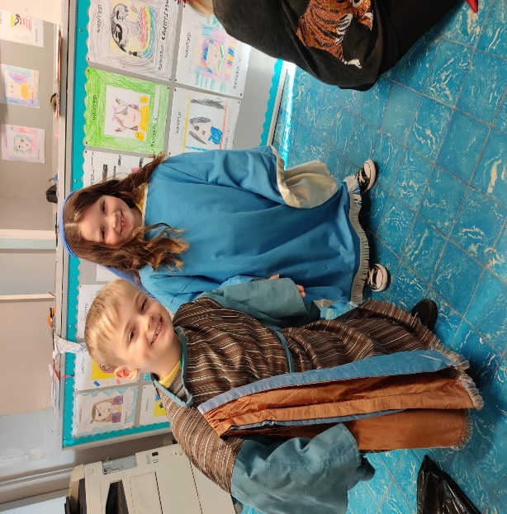
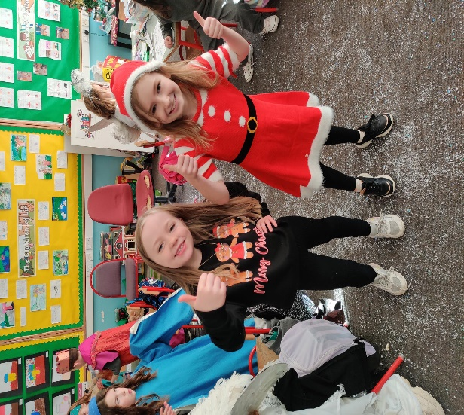
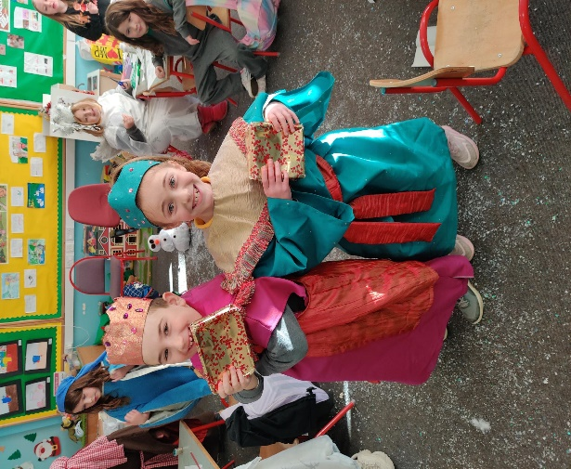

This is a very musical year for St. Benedict’s and St. Mary’s. All our classes participate in the Music Generation programme which is an excellent interactive initiative whose mission is to “create inspiring experiences for children and young people through music.” Our children look forward to their lessons with Keila and Balbina every Tuesday, where they learn singing, dancing and the musical rudiments. Children from 3rd- 6th class are also involved in the Peace Proms choir. The choir recently attended a rehearsal with other schools and the conductor, they learned new skills and inspired other children with their enthusiasism and crazy dance moves! The choir will perform in the RDS, on Saturday 4th February, with a full orchestra and over 2,000 other choir members!
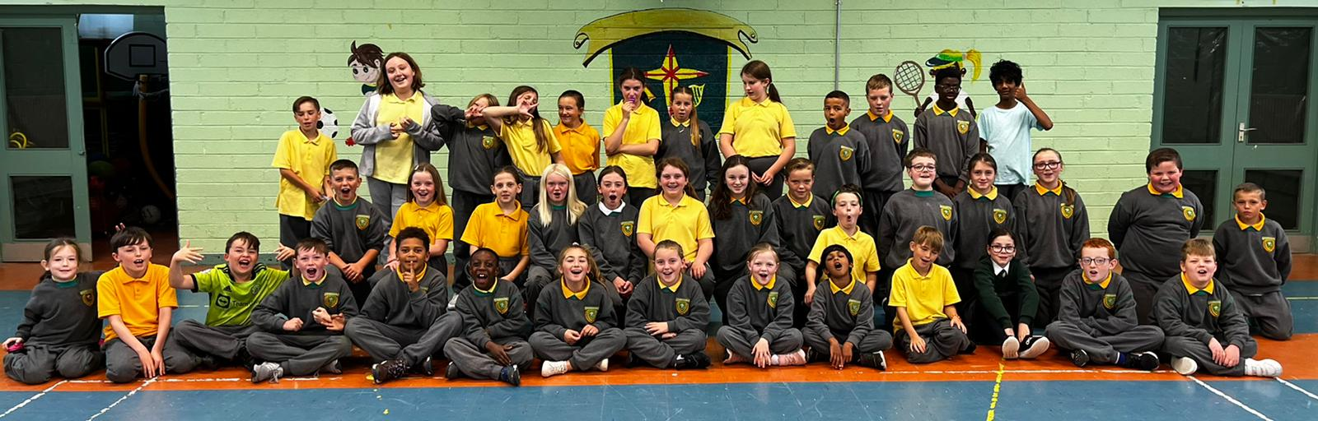
PEACE PROMS CHOIR

