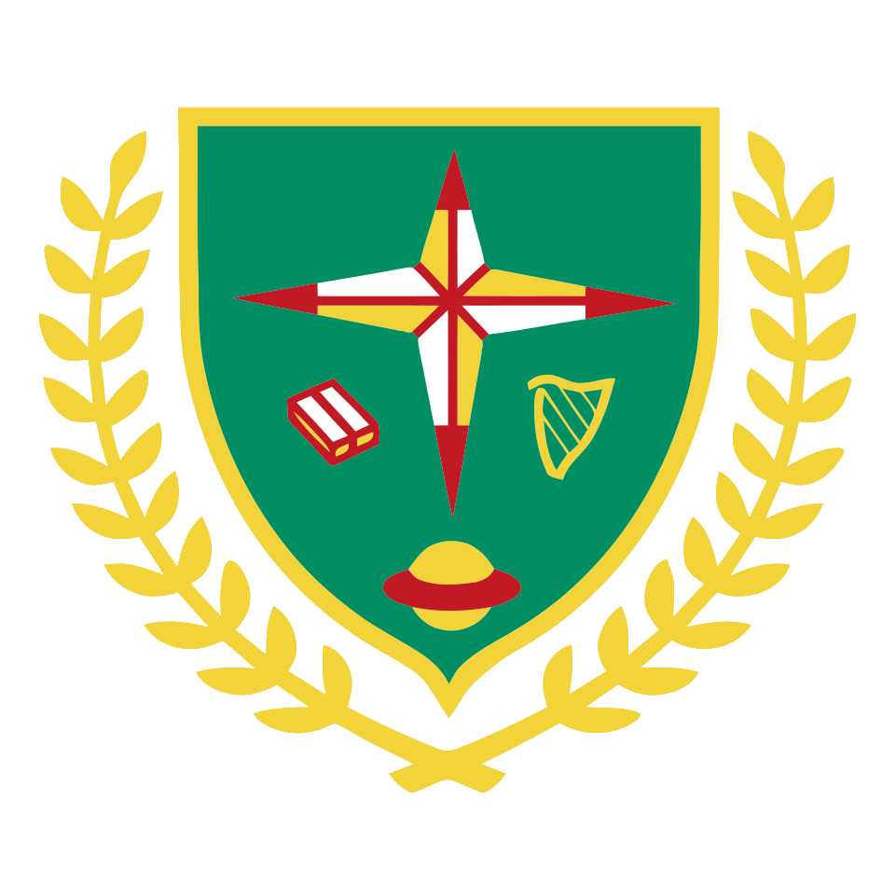
Beno’s Bulletin
November 2020 Issue No. 1

Covid & Us – A Principal’s Story
How one Principal made it safe
By Bobby Power, Charlie Clarke, Faye Fallon, Braxton Hopkins, Alanna Cummins & Ryan Moore
In March 2020 our school closed because of Corona Virus. We thought school would be closed for two weeks but it was closed for nearly six months.

We interviewed Ms. Plunkett to find out about how the school has changed because of the Corona Virus. Ms Plunkett told us “it was a lot of work at the beginning and through the summer” to prepare the school to re-open because it had to be safe for the children and the school staff. All the school staff helped prepare the school
and she had a lot of help from Petre and her Dad who helped drill forty sanitisers into the walls around the school.
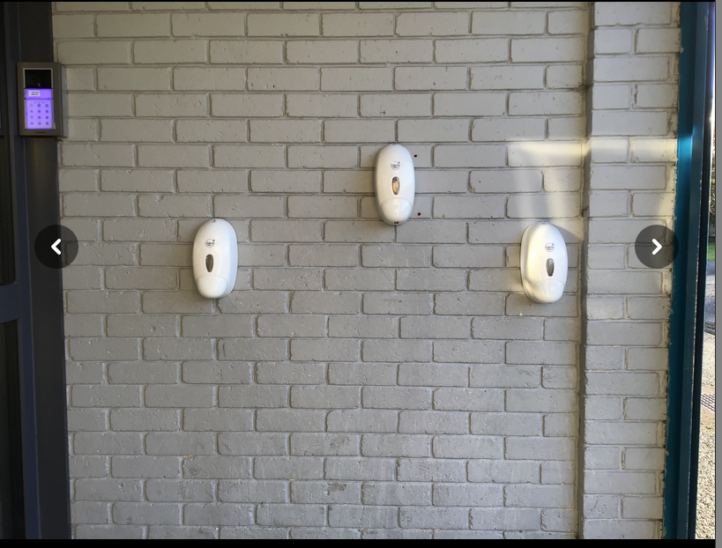
Photographer: Braxton Hopkins

There are a lot of changes this year in school, we have dots to socially distance when we are lined up, every class has their own section on the yard, we have new hand washing and sanitising routines, we are in pods in the class, we have boxes for our books and copies, P.E is outside and the teachers wear masks.
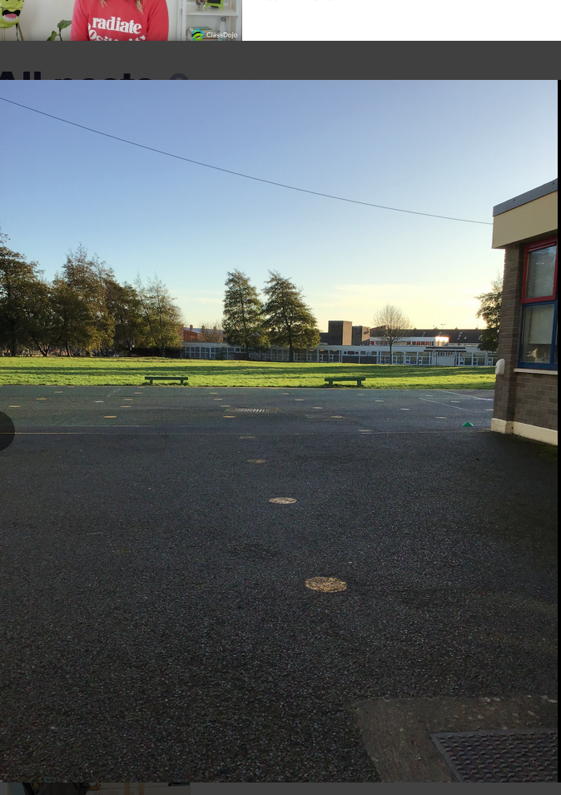
Photographer: Braxton Hopkins

We asked Ms. Plunkett if the teachers are spaced out in the staff room and she told us that they are spaced out and that “last year there was one staffroom but this year there are three.” The school staff have two staffrooms and the preschool are using the Wiggle room as their staffroom. Ms. Plunkett also told us, “When the teachers are finished their lunch they clean their tables and chairs, if they touch a switch or handle they sanitise before touching it, after touching it and clean the switch or handle.”

If you are sick stay at home. We need to continue washing our hands, keeping our distance and covering our mouths and noses when we sneeze or cough to keep ourselves and everyone else healthy.

Luxury Bug Hotel Arrives in St. Benedict’s and St. Mary’s.
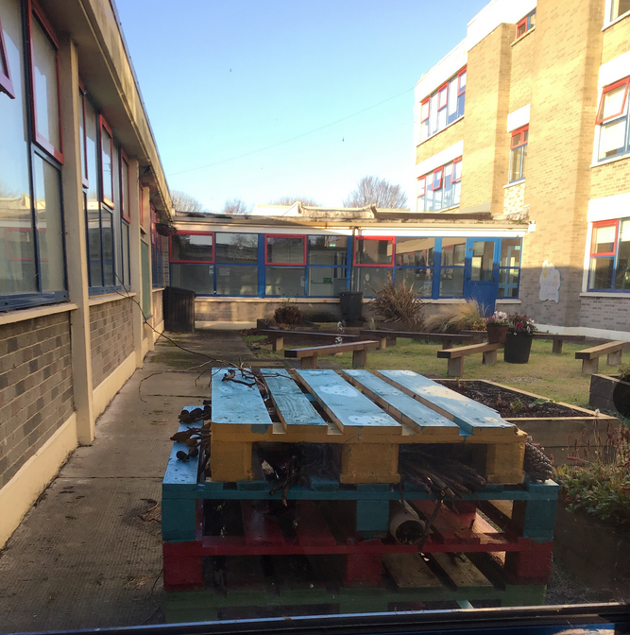
By: Clayton Smith, Daisy Halpin, Kayla O’Loughlin, Lacey Daly, Kyra Kelly, Kara Mulligan and Ella Rose Maguire.
Photographer: Daisy Halpin
The school garden is now home to a new luxury bug hotel. Bug hotels create a nature friendly environment.
We interviewed Ms. Casey to discuss the bug hotel. Ms. Casey told us the boys and girls in the senior end of the school came up with the idea for the bug hotel.
Ms. Casey, Petre and children throughout the school helped create the bug hotel.
The hotel is made from wooden pallets and painted in rainbow
colours. The hotel is painted rainbow colours because it fits in with our colourful school. It is filled with twigs, sticks, leaves, acorns and hay to attract insects.
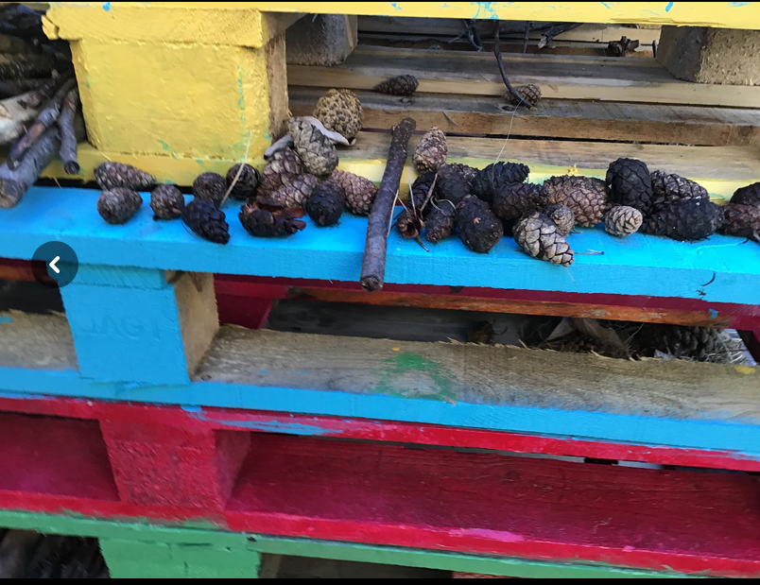
Photographer: Daisy Halpin

The insects like the twigs and sticks because they can crawl in maround them and hide. The bug hotel is a quiet and cosy place for the creatures to sleep. Ms. Casey also told us that sometimes “birds will visit the
bug hotel for food”, the birds will eat the insects inside.
We asked Ms. Casey what her favourite creature is and she told us it is the Ladybird because they eat pests such as greenflies. Small creatures like ladybirds, woodlice, spiders and earwigs will visit the hotel.

Bird Breach
By: Clayton Smith, Daisy Halpin, Kayla O’Loughlin, Lacey Daly, Kyra Kelly, Kara Mulligan and Ella Rose Maguire.

On Thursday 19th November, while 2nd class were coming in from running a brown bird flew into the school. The bird was a Sparrow Hawk.

The bird was flying around the corridor and hitting the windows by the beach garden.
Daisy, Braxton, Kyra and Bobby witnessed the bird flying around the corridor. “The bird flew over my head!” said Braxton. Kyra tells us “It kept flying and flying. I was scared. I was frozen like a statue”.

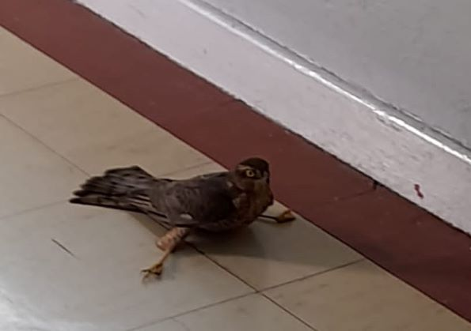
Ms. McGuinness and Ms. Clarke were on the corridor and tried to help the bird leave by opening the fire doors but it would not go out and flew up to the office.
Photographer Ms. Clarke

Ms. McGuinness opened the office door and Ms. Clarke tried to hoosh it out but it still would not leave. The bird eventually left when both doors were opened.
Ms. McGuinness told us she was terrified but Ms. Clarke was not and she took a picture of the bird

We Run The World

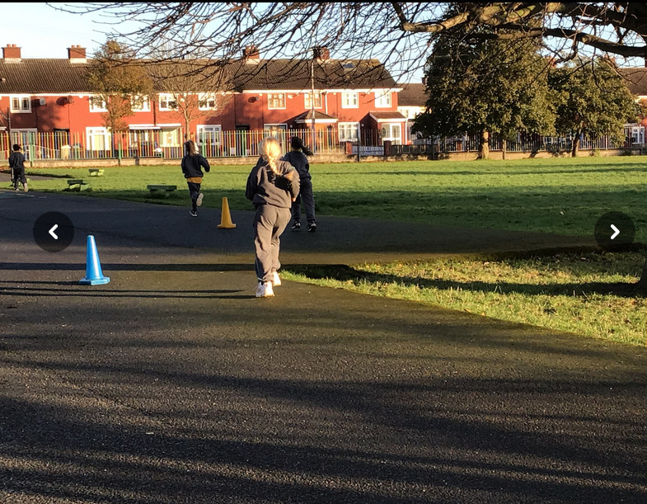
By: Amber Evans, Kye Dowling, Darcey Burke, Robyn Gallagher, Savannah Kelly and Ronan Kelly.
Photographer: Ronan Kelly

Here in St. Benedict’s and St. Mary’s we are very active. We go on walks after break, exercise, do 10@10 and Just Dance. We are trying to get an Active Flag
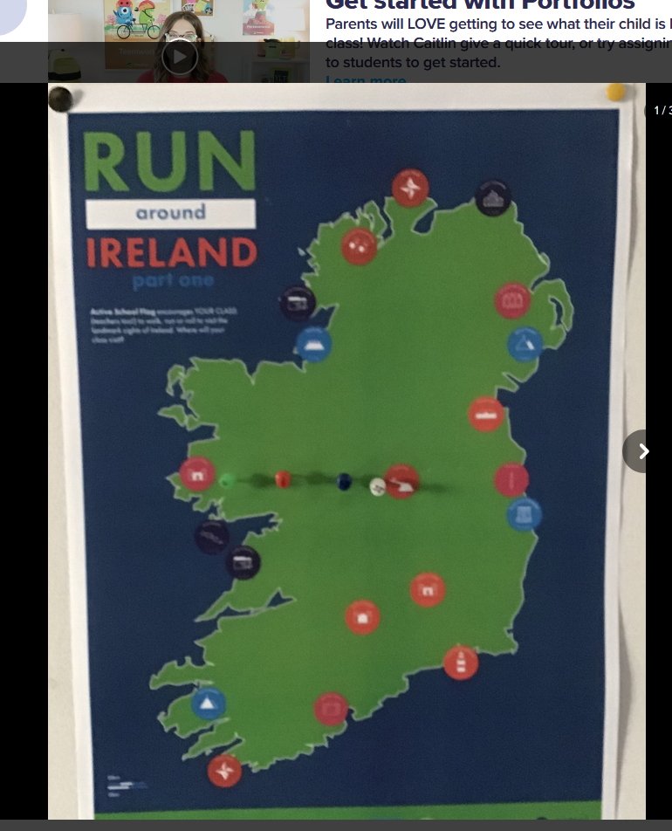
We interviewed Mr. Lyons to learn more about the active flag. He told us you have to be active to win the active flag. The active flag is yellow and would fly on
the flag pole in the school with our other flags.
We are now doing a
Run Across Ireland / Europe Challenge.
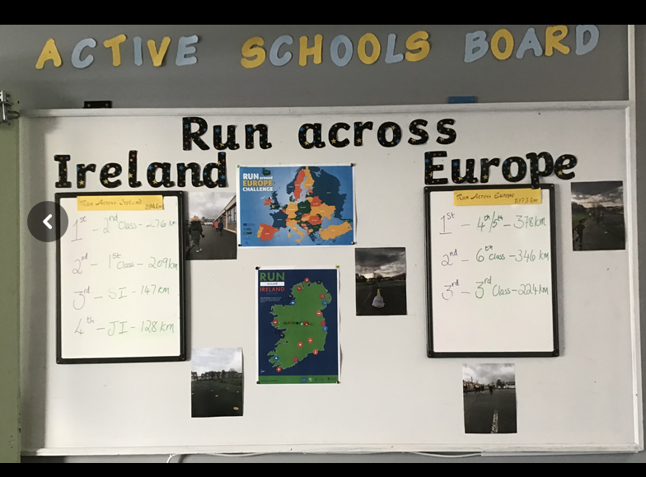
We are enjoying the running challenge and Mr. Lyons told us that he and his class are too. He also told us that other sports like cricket, football, rugby, dancing and gymnastics will help us get the active flag and that he would like to try and organise coaches to come in and teach us. When we asked Mr. Lyons if he thinks we will get the active flag, he told us he has “no doubt” that we will.
Photographer: Ronan Kelly

So far 2nd class are in the lead in the running challenge for the junior end of the school and 4th/5th are leading in the senior end.

Exercise is important because it helps keep our bodies and minds healthy. We are trying very hard and we are getting fitter from running. We have to keep being active to win the active flag and continue being active after we get it to keep it.

Beno’s Brainteasers
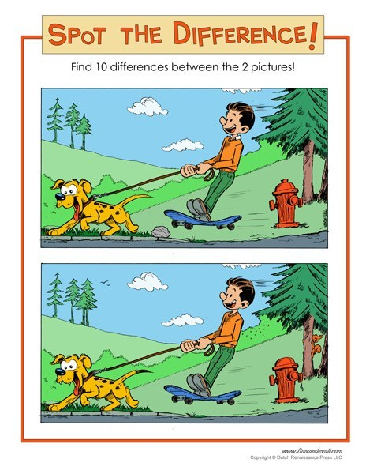

What has a face and two hands but no arms or legs?

What word begins and ends with an E but only has one letter?

What has to be broken before you can use it?

What is so delicate that saying its name breaks it?

Answers: Clock, Envelope, an egg & silence

