AISTEAR
We all love to play and here in St. Benedict’s we really do value play. Play is vital in the development of all children and our pupils love our school’s playful learning style as it makes their time here enjoyable and fun.
Aistear is the name of the play curriculum in Ireland and we are very fortunate to have the highly renowned and certified Aistear tutor, Ms. A. Flynn on our staff.

READING RECOVERY
We are very fortunate to have Reading Recovery teachers on our staff.
These teachers provide an intensive one to one reading programme to assist children in the area of literacy and provide them with the foundation blocks for their future education.

MATHS RECOVERY
This project is as an extension of the successful Maths Recovery programme with a view to extend this method into whole class, small group and one to one teachings.
Due to our participation in the project, several of our staff are certified Math’s Recovery teachers and we have some of the very best resources to implement this programme at every class level.

THE SCHOOL DAY
School opens at 8.40am.
School closes at 1.25pm for Junior and Senior Infant level
School closes at 2.25pm for First to 6th class level

It should be noted that your children may not enter the school before 8.40am.

BOOK RENTAL SCHEME- (BRS) for pupils of Junior Infants to 6th class costs €90. The scheme includes all text books, workbooks, pencils, copies, rulers, pens etc. and covers the cost of Art/Craft, Photocopying and Testing. Payment in full must be made in June each year. Reduction for siblings.
ATTENDANCE- Good school attendance is crucial to your child’s education. An explanation for absence can be submitted on Aladdin, otherwise a written note from parent/guardian is required. Please avoid arranging holidays at times during the school year as these absences will be included when calculating days absent.
ABSENCES – All absences of 20 days or more in the year must be reported to the National Education Welfare Board, this is not discretionary. The school is striving to raise attendance levels and you will be notified if a child reaches10 days absence and again at 15.

PUNCTUALITY - The children are expected to be punctual and attend school every day. The school requests parents to ensure that their children are on time for school and that their children remain in school for the full school day. We encourage attendance from 8.40am.

HALF DAYS - If children are taken out during the school day there must be a full legitimate explanation and/or appointment card by a legal guardian or parent only. Half days constitute a half absence on roll books and will be recorded as such on Aladdin.

CODE OF BEHAVIOUR - All schools operate a Code of Behaviour for dealing with behaviour. Our school places greater emphasis on rewards than on sanctions in the belief that this will, in the long run, give best results.

Our code of behaviour operates on the respect the staff have for the children and likewise the respect the pupils have for the staff.

PARENT/TEACHER MEETINGS - Parent/Teacher meetings are held during the year and give parents/guardians an opportunity to meet the teacher and talk about their child’s progress and any concerns they may have.

APPOINTMENTS - If you need to speak to the Principal or Teacher at any time during the year we ask that you make an appointment with the Secretary for a time when the teacher can arrange supervision of the class. Principal appointments are strictly between 9.00 – 10.00 am. When visiting the school, you must check in with the Secretary before proceeding through the building. This is a matter of Child Protection and must be enforced to ensure the safety of our pupils.

HSCL - The importance of parents and teachers working together for the benefit of the children under our care cannot be over emphasised. We are proud of our very successful Home School Community Liaison Scheme and our aim is to support you in the holistic development of your child.

UNIFORM - The school uniform must be worn every day. Our School uniform is generic and may be purchased locally in Dunnes Stores. It consists of a Grey pullover, Grey Shirt, Grey Trousers and School Tie or Green Pullover, White Shirt, Grey Skirt and School Tie. The school Tracksuit, Polo Shirt and school tie are available at Pat O’Farrell Schoolwear, Portmarnock.
PHONES – Mobile phones are unnecessary for a primary school child and are often used as a tool for cyberbullying. They are therefore completely banned in this school. Parents should make arrangements regarding collection after school with their child before they leave home each day.
LUNCHES - In conjunction with the Dept. of Social and Family Affairs, we are fortunate to be able to provide a healthy morning snack and healthy lunch for our pupils daily. Fizzy drinks, fruit juices, crisps, sweets, chocolate, chewing gum and “junk food” are banned.
All leftover lunch to be brought home.

GREEN SCHOOL - We currently have Four Green Flags which were awarded to us for our work and projects on recycling, water and energy. We are now working on our fifth Green Flag.

CHILD PROTECTION –

DLP (Designated Liaison Person) Ms. J. Plunkett Principal

DDLP (Deputy Designated Liaison Person)

Ms. A. Flynn

Included in the Junior Infant Welcome Pack are copies of:

Child Safeguarding Statement

Data Protection Policy

Code of Behaviour

DEAR PARENTS/GUARDIANS,

Welcome to our wonderful little school.

Our motto of “Love, Laugh, Learn” is at the forefront of everything we do at St. Benedict’s & St. Mary’s N.S. and we will strive to have your child experience this as they begin their journey here.

Your child’s happiness and well-rounded educational experience is paramount to us.

St. Benedict’s & St. Mary’s provide various programmes, supports and learning methodologies to reach every child. We have expert staff trained in the areas of special education, literacy, numeracy, play, nurture, sport and the arts.

NURTURE
Wellbeing is the current buzz word in education. A school community that’s “well” provides a safe, healthy and emotionally literate environment for children.
Our Nurture Room provides a structured intervention for children requiring additional support.

Although wellbeing is new on the Department of Education’s agenda, it has always played a central role in our little school.

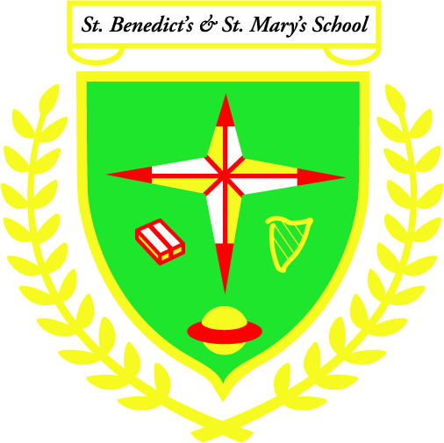

St. Benedict’s & St. Mary’s N.S.
stbenoffice@gmail.com
Tel: 01 8470202

INFORMATION BOOKLET

“Love Laugh Learn”

