Beno’s Bulletin
December 2021
Issue No.5

Word has reached me of a truly Christmas
School filled with happy children and kind
teachers who spread joy and kindness to
others, a school full of carol singing, twinkling
lights, Christmas trees and decorations and
I heard about a new playground too, it
sounds like a place I’d like to visit.
Everyone in St. Benedict’s including
Ms. Plunkett are now officially on the
Nice List for being the most Deliciously, Tinselly,
Puddingly, Christmassy friends of Santa.
Santa

What Christmas means to me in 5 words or less
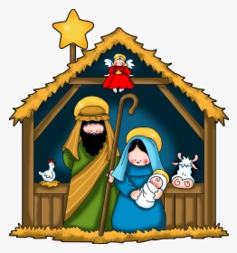
About our families and friends – Kye Dowling
Spending time with my family – Clayton Smith
Happy, giving, presents and fun – Robyn Gallagher
Jesus’ Birthday and family – Mason Coogan
Family, friends, presents, Christmas dinner – Amber Evans
Giving gifts and receiving gifts – Ronan Kelly
Family, Joy, giving, Christmas Dinner – Lacey Daly
Having a party – Alanna Cummins
Family, dinner, friends, Jesus, God – Faye Fallon
Seeing cousins from another country – Daisy Halpin
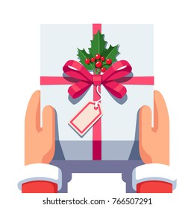
Family, presents, food, money, love – Lacey
Pudding, family, friends, food laughter – Kenai
Family, joy, food, presents, excitement – Sophia
Loving, family, together, food, presents – Mason
Roast, pressies, grand parents, family – Alfie
Cookies, money, joy, shopping, family – Lucy
Family, love, kindness, giving, goodness – Morgan
Joy, family, kindness, friends, food – Namish
Joy, family, matching PJ’s, movies, dinner – Ben
Family, cookies, presents, food, joy – Holly
Family, friends, presents, money, love – Emily
Family, food, presents, Jesus, friends – Ella

Ariya has 2 wobbly teeth…..James has 5 fingers….. Juliet went to the playground……Hudson got a bumblebee teddy bear……Casey saw Santa and his elves in auntie Ann’s…..Finn and Ryan saw 2 rats…..Tyler saw a boy fall off his bike…..Sadie’s elf put toilet roll all over the house…..Jasmine made 10 cards for her nanny coz she loves her so much…..Jayden went to a disco…..Aaron and Jamie got a cat…..Zara Rose’s elf was in her room….Deborah said she went to the Christmas…..Bobby’s dog does not like Kye…..Clayton spilled his milkshake on himself…..Darcey’s elf painted her dads toenails…..Mason got a new house for Christmas…..Kara’s elf was drinking all the milk…..Bobby went to see the new Spiderman…..Faye’s cousin had a sleepover in her house

Eoghan in Sen Infants…. Knock Knock… Who’s there? cat….. cat who?..... cat dog.

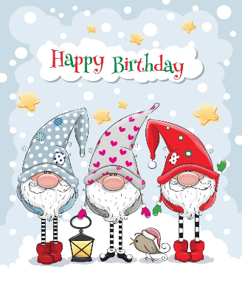
Happy Christmas Week Birthdays To:

Kris Kringle Christopher Doyle
Jingle Bell Isabelle McMahon
Ding Dong Dylan O’Reilly

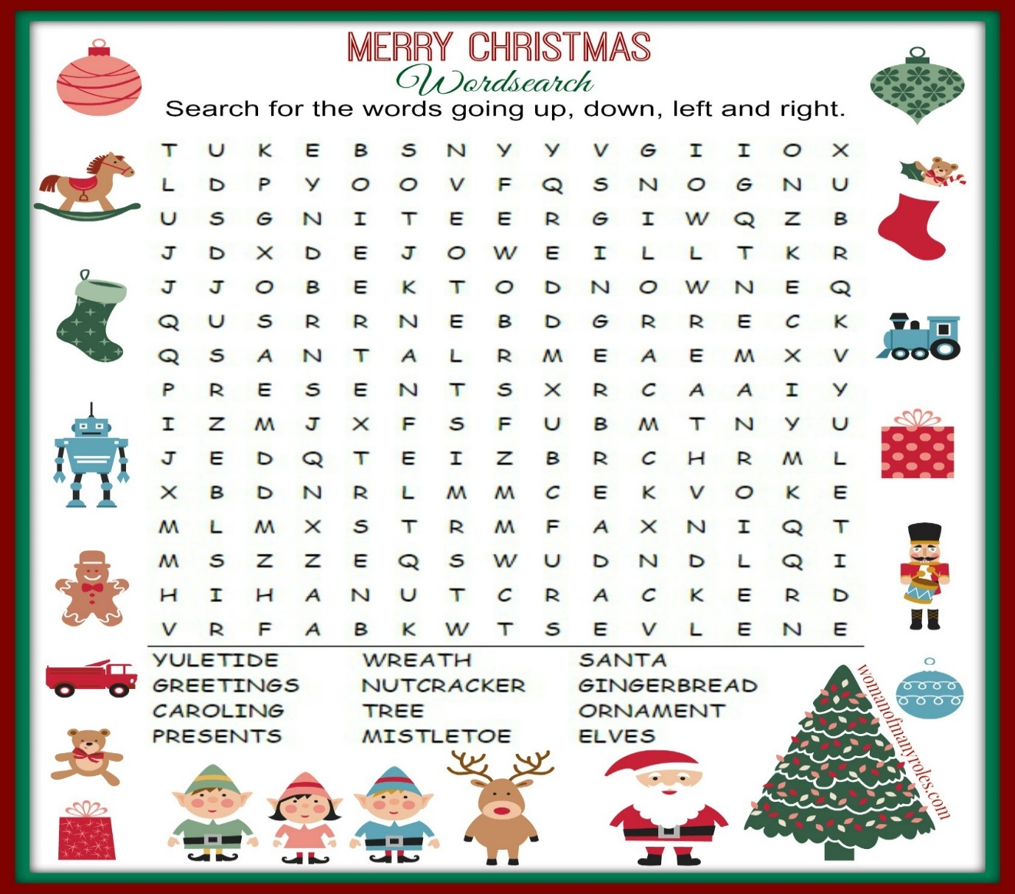

Merry Christmas Everyone

